Task 1: Installation Process of various operating systems.

Windows OS (Operating System) is a collection of operating systems created by Microsoft. It's designed to manage computer hardware and software resources while providing common services for computer programs.

Here are some key points about Windows OS:

* **User Interface**: Windows OS provides a graphical user interface (GUI) that allows users to interact with the computer through visual elements like windows, icons, and menus.
* **Multitasking**: It enables users to run multiple applications simultaneously, making it easier to switch between tasks.
* **Compatibility**: Windows supports a wide range of hardware and software, making it versatile for different types of users, from gamers to professionals.
* **Networking**: It includes built-in networking capabilities, allowing users to connect to the internet and other devices easily.
* **File Management**: Windows provides tools for organizing, searching, and managing files and folders efficiently.

Some popular versions of Windows OS include Windows 7, Windows 8, Windows 10, and the latest Windows 11. Each version brings new features and improvements to enhance user experience and performance.

**Windows 10 Edition***:* Windows 10 comes with several editions tailored to different types of users and use cases. Here are some of the main editions:

**Windows 10 Home**

* **Target Audience**: General consumers
* **Features**: Basic functionality, including Cortana, Microsoft Edge, Windows Hello, and basic security features.

**Windows 10 Pro**

* **Target Audience**: Small businesses and power users
* **Features**: Includes all Home features plus BitLocker, Group Policy management, Remote Desktop, and enhanced security options.

**Windows 10 Enterprise**

* **Target Audience**: Large enterprises and organizations
* **Features**: Includes all Pro features plus advanced security and administration features, such as Device Guard, Credential Guard, and Windows Defender Advanced Threat Protection.

**Windows 10 Education**

* **Target Audience**: Educational institutions and students
* **Features**: Similar to Enterprise but tailored for schools, including tools for classroom management and collaboration.

**Windows 10 Mobile**

* **Target Audience**: Mobile devices and smartphones
* **Features**: Optimized for touch and mobile experiences, includes Continuum for a PC-like experience on supported devices.

Each edition offers specific features and capabilities designed to meet the needs of different users, from casual consumers to large enterprises.

**Windows 10 Minimum System Requirements:**

* **Processor**: 1 gigahertz (GHz) or faster processor or System on a Chip (SoC)
* **RAM**: 1 GB for 32-bit or 2 GB for 64-bit
* **Hard Disk Space**: 16 GB for 32-bit OS or 32 GB for 64-bit OS
* **Graphics Card**: DirectX 9 or later with WDDM 1.0 driver
* **Display**: 800 x 600 resolution

**Installation of windows 10**

There are two common methods to install Windows 10 on a device:

**1. Using a Bootable USB Drive with Rufus**

* **Create a Bootable USB Drive**: Download the Windows 10 ISO and use a tool like Rufus to create a bootable USB drive.

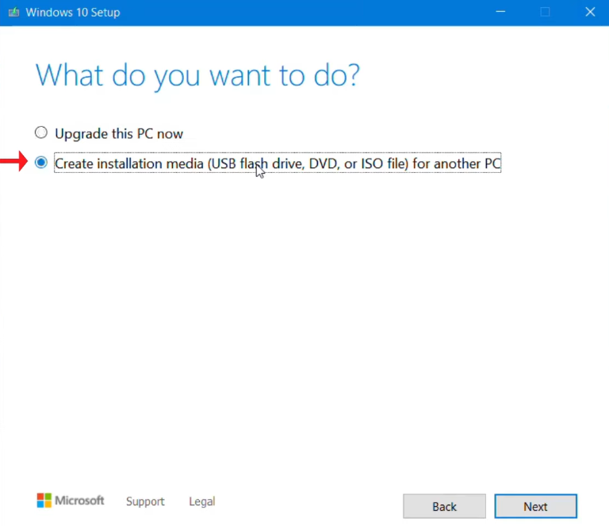

Fig1.0 Creating ISO image file of Windows10 using Windows Media Creation Tool

* **Install Windows 10**: Boot from the USB drive and follow the on-screen instructions to install Windows 10.

**2. Using the** **Windows Media Creation Tool**

* **Create Installation Media**: Download the Windows Media Creation Tool, and use it to create a bootable USB drive.
* **Install Windows 10**: Boot from the USB drive and follow the on-screen instructions to install Windows 10.

**Steps to install windows 10 using Rufus:**

**Step 1: Download Windows 10 ISO**

1. Go to the official Windows 10 download page.
2. Use the Windows Media Creation Tool to download the Windows 10 ISO file. Run the tool and follow the on-screen instructions to download the ISO

**Step 2: Download Rufus**

1. Go to the official Rufus website and download the latest version of Rufus.
2. Rufus doesn't require installation, so you can run it directly after downloading.

**Step 3: Create Bootable USB Drive with Rufus**

1. Insert a USB flash drive (at least 8 GB) into your computer.
2. Open Rufus.
3. In Rufus, select your USB flash drive from the "Device" dropdown menu.
4. Under "Boot selection," choose "Disk or ISO image" and click on the "SELECT" button to browse and select the Windows 10 ISO file you downloaded.
5. Ensure the following settings are selected:
   * **Partition scheme**: GPT (for UEFI) or MBR (for BIOS)
   * **Target system**: UEFI (non-CSM) or BIOS (or UEFI-CSM)
   * **File system**: FAT32 or NTFS (NTFS is recommended for larger drives)
   * **Cluster size**: Default (4096 bytes)
   * **Volume label**: Name the USB drive (e.g., "Windows 10")
6. Click on the "START" button. Rufus will warn you that all data on the USB drive will be erased1. Confirm to proceed.
7. Wait for Rufus to create the bootable USB drive. This may take a few minutes.

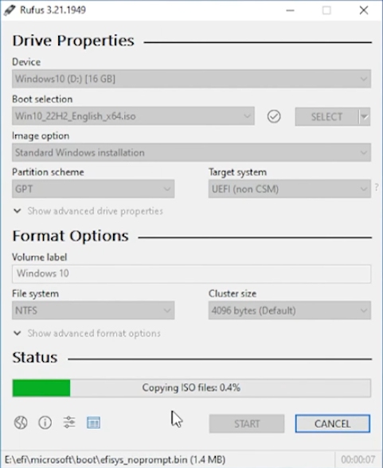

Fig1.1 creating boot drive using rufus

**Step 4: Install Windows 10**

1. Insert the USB Drive: Plug in the bootable USB drive to the PC where you want to install Windows 10.

2. Restart: Restart the computer and enter the BIOS/UEFI settings (usually by pressing F2, F12, DEL, or ESC during startup).

3. Boot from USB: In the BIOS/UEFI settings, set the USB drive as the primary boot device.

4. Begin Installation: Save the settings and restart. Your PC should boot from the USB drive. Follow the on-screen instructions to install Windows 10, including selecting your language, time, keyboard preferences, and entering your product key if required.

5. Complete the Setup: Proceed with the rest of the installation steps, such as selecting the drive where you want to install Windows 10 and configuring Windows settings.

**Steps to install windows 10 using Rufus** **Windows Media Creation Tool**:

**Step 1: Download the Windows Media Creation Tool**

1. Go to the official Windows 10 download page.
2. Click on the "Download tool now" button to download the Media Creation Tool.

**Step 2: Run the Windows Media Creation Tool**

1. Open the Media Creation Tool file you just downloaded.
2. Accept the license terms.

**Step 3: Create Installation Media**

1. Choose the "Create installation media (USB flash drive, DVD, or ISO file) for another PC" option and click "Next."



1. Select the language, edition, and architecture (32-bit or 64-bit) for Windows 10, then click "Next."

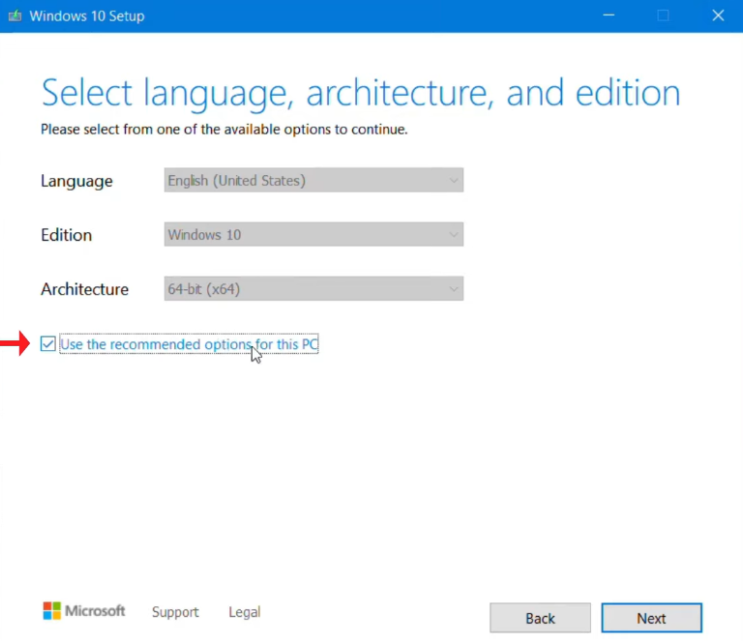

1. Choose "USB flash drive" as the media to use, and click "Next."

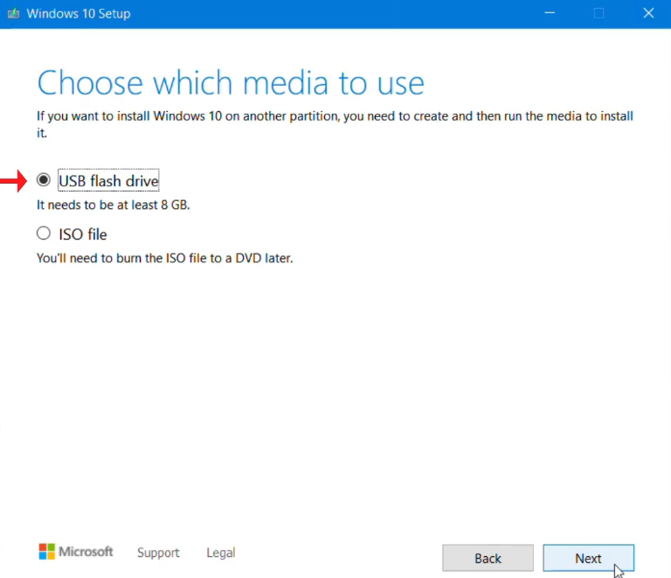

1. Insert a USB flash drive (at least 8 GB) into your computer. The tool will detect the USB drive, select it, and click "Next."

**Step 4: Create Bootable USB Drive**

1. The Media Creation Tool will download Windows 10 and create the bootable USB drive. This process may take some time, depending on internet speed.
2. Once the process is complete, click "Finish."

**Step 5: Install Windows 10**

1. Insert the USB Drive: Plug in the bootable USB drive to the PC where you want to install Windows 10.

2. Restart: Restart the computer and enter the BIOS/UEFI settings (usually by pressing F2, F12, DEL, or ESC during startup).

3. Boot from USB: In the BIOS/UEFI settings, set the USB drive as the primary boot device.

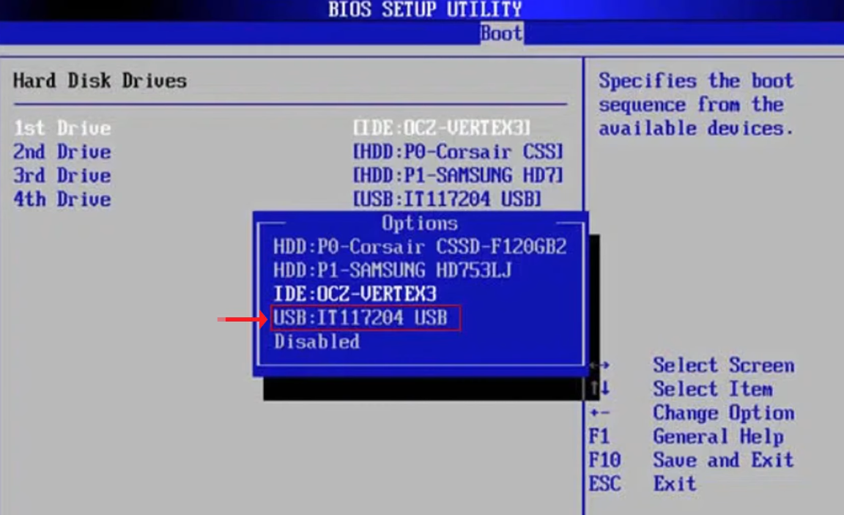

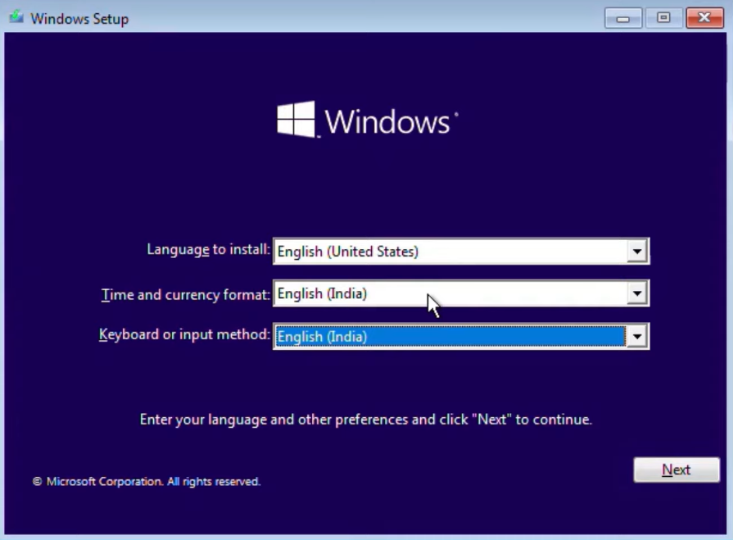

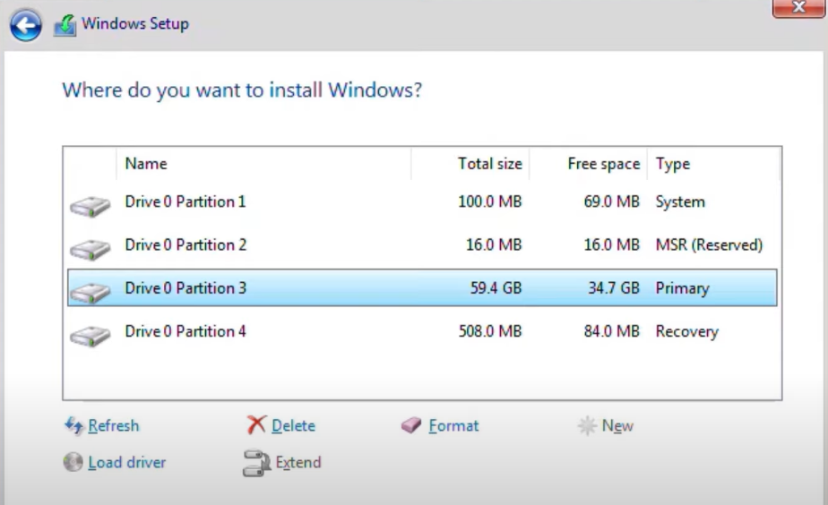

4. Begin Installation: Save the settings and restart. Your PC should boot from the USB drive. Follow the on-screen instructions to install Windows 10, including selecting your language, time, keyboard preferences, and entering your product key if required.

5. Complete the Setup: Proceed with the rest of the installation steps, such as selecting the drive where you want to install Windows 10 and configuring Windows settings.

